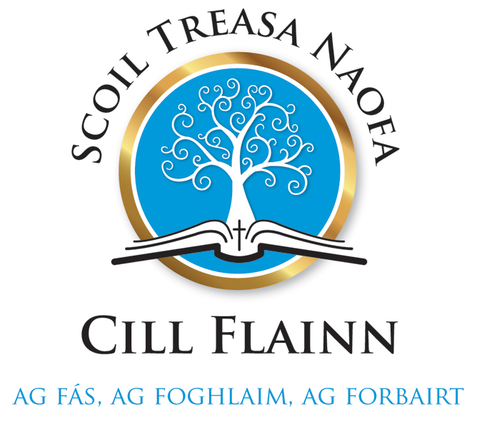
UNIFORM POLICY
POLICY RATIONALE
The wearing of our school uniform and school tracksuit is of huge importance. It reinforces a child’s association with the school and creates an identity and image for and of the school. Therefore, parents are required to provide their child with the designated uniform and pupils are required to wear their full uniform, without modification.
This policy is linked to the school’s Code of Behaviour and School Rules.

CONSULTATION
This policy arises from the complete revision of our previous Uniform Policy. It was worked on by the teachers of the school during the school year 2018/2019.
It is hoped that the redrafted version will be a useful tool for teachers providing them with clear guidelines and ensuring consistency and continuity in practice throughout the school.

SCHOOL UNIFORM:
The uniform of Scoil Treasa Naofa is as follows: (See attached pictures)
- Navy skirt, navy pinafore (Knee length)
- Navy trousers (Junior & Senior infants must wear trousers with an elasticated waist)
- Deerpark royal blue v-neck jumper
- Deerpark royal blue cardigan
- Blue and grey tie
- Navy tracksuit with school crest
(All the items listed above are available to purchase from Shaws, Tralee. Alternatively, skirt, pinafore and pants may be purchased in Dunnes Stores in the styles circulated to parents.)

Other items of uniform include the following:
- White long-sleeved shirt to be worn with uniform- NOT polo shirt
- White short-sleeved polo shirt to be worn with tracksuit
- Navy/black socks or tights
- Flat black or navy shoes/trainers that are supportive of children’s growing feet are to be worn. For health and safety reasons, NO HEELS, PLATFORMS or HIGHTOPS are allowed.
- Black or navy trainers must be worn on P.E. days and may be worn on the other 3 schooldays also.
- Plain, flat black boots are allowed provided they can be worn INSIDE the trousers’ legs.
- Footwear recommended by a medical professional is permitted. Written confirmation of such a recommendation must be given to the Principal.
- Junior and Senior Infants are required to have Velcro fastening on their shoes/runners.

SCHOOL TRACKSUIT
The school tracksuit must be worn on days when Physical Education (P.E.) is listed on class timetables. In Scoil Treasa Naofa, all classes have P.E. lessons on Monday and Thursday each week.

GENERAL APPEARANCE OF PUPILS
- As a general rule, during classroom lessons, pupils must not wear jackets, fleeces or scarves over their uniform nor headgear such as hats or caps.
- Stud earrings and watches are the only items of jewellery allowed. Pupils may only wear one stud earring in the lower lobe of each ear. No other piercings are allowed as they may be a source of danger.
- Dyed hair, make-up, fake tan or coloured nail varnish are not allowed.
- In the interest of hygiene, long hair must be tied up at all times.
- Hair should be checked regularly for headlice as it is a national problem.
For maximum effectiveness, parents are requested to carry out these checks on a common day.
Should there be an outbreak of headlice in the school, all parents will be informed by note and requested to take immediate action to treat the infestation.

COMPLIANCE WITH POLICY
- As part of the daily school routine, class teachers will visually check that the full uniform is being worn. If the dress code cannot be adhered to on a particular day, an explanatory note is required from parents.
- Failure to provide an explanatory note within three school days may result in parents being contacted by their child’s class teacher.
- Class teachers will also visually check for compliance with points 1-4 under the heading “GENERAL APPEARANCE OF PUPILS”. If non compliance of the above occurs, a note may be sent home (see attached).

NAME TAGS
It is essential that all items of uniform and other clothing are clearly labelled with child’s name throughout the entire school year.

RATIFICATION
This plan was ratified by the Board of Management of Scoil Treasa Naofa following staff distribution and discussion. A copy of the Uniform Policy is available to view outside the Principal’s office.

Chairperson of BoM ______________________ Date _________________
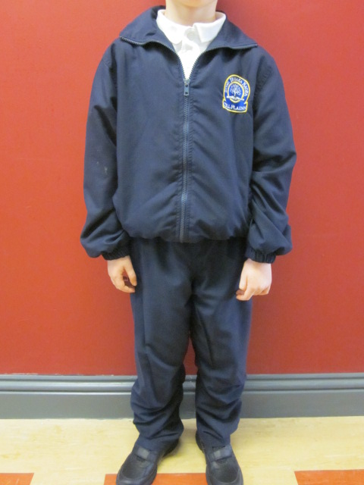
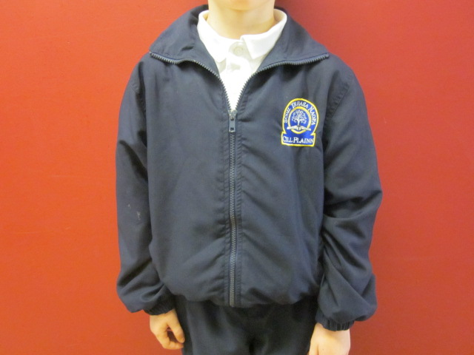
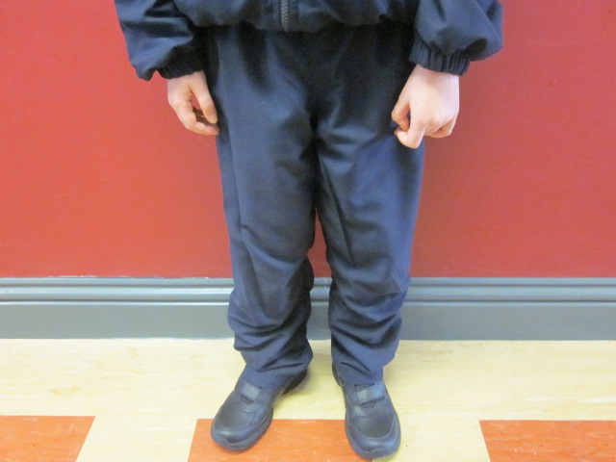

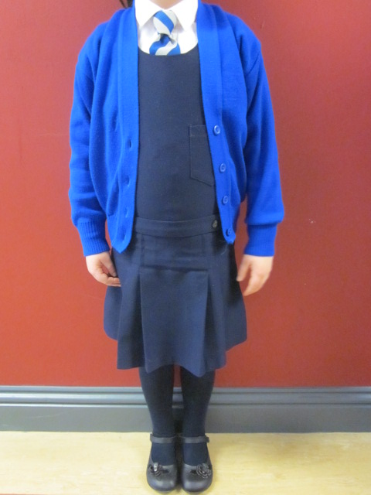
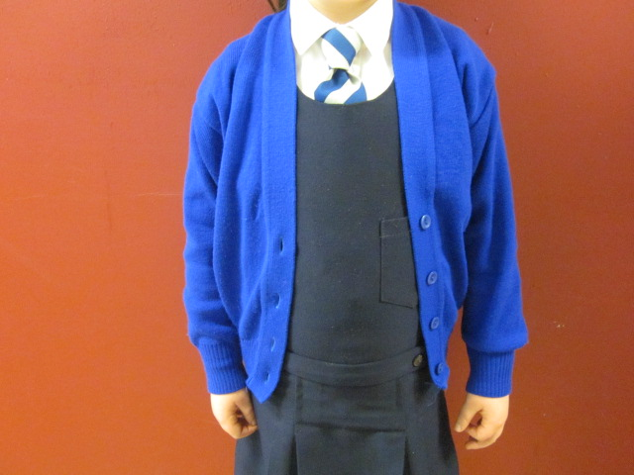
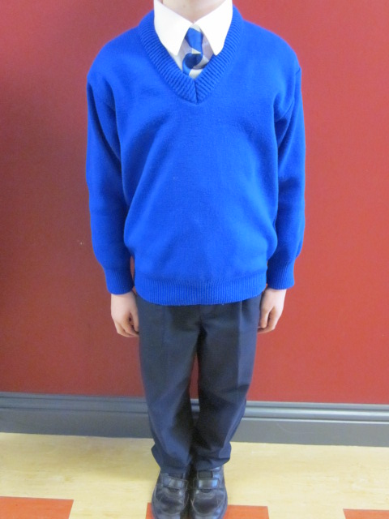
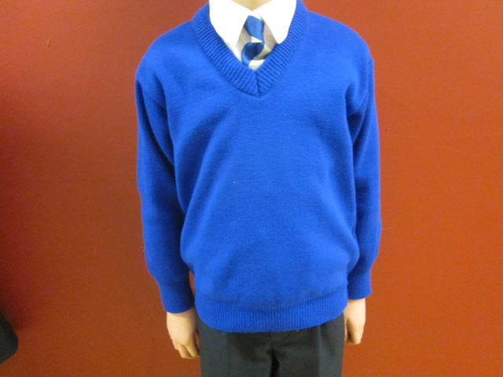
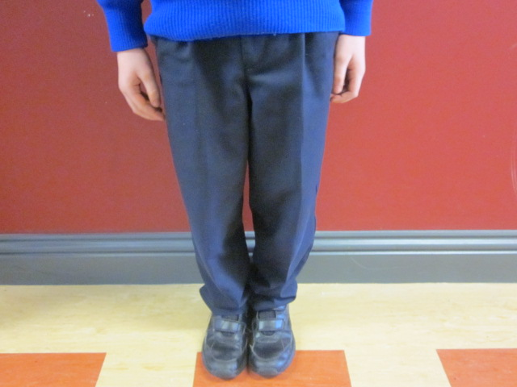
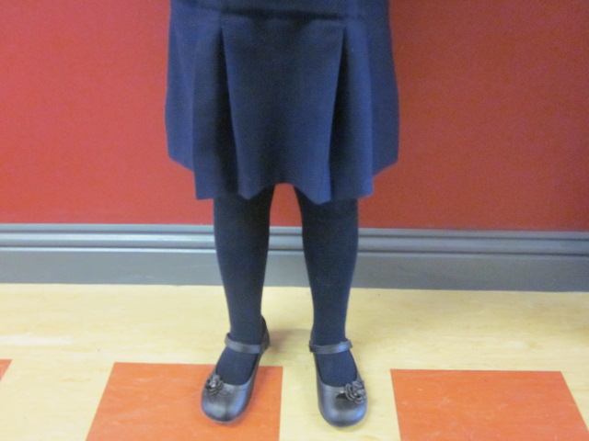

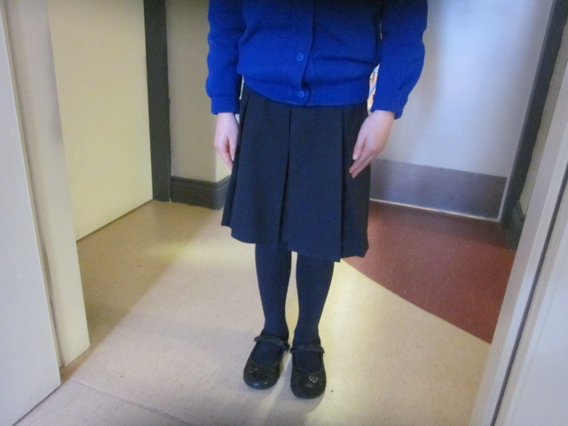
Date: ..........................................

Dear Parents/ Guardians,

It has come to our attention that your child is wearing incorrect school uniform.
We would like to work with you to ensure that all our children are in the correct uniform to represent Scoil Treasa Naofa whilst at school and also in the wider community.
Today your child....................................................... came to school wearing inappropriate uniform:

Item of Inappropriate Uniform Worn
Shoes |  | Nail varnish
Trousers |  | PE kit
Jumper |  | Socks/tights
Skirt |  | Jewellery
Shirt |  | Makeup
Tie |  | Fake tan

Any further information regarding the inappropriate uniform may be provided below: ..................................................................................................................................................... .....................................................................................................................................................

Please ensure that they are in the correct uniform tomorrow.
If there are any issues please contact the school.

Yours sincerely
...............................................................

